Kigali To Turn All Major Wetlands Into Eco Parks

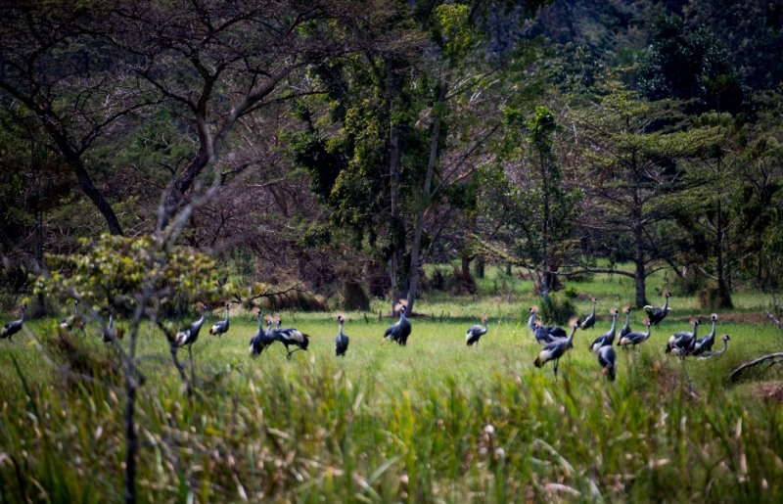Kabuga wetland where already efforts started to bring in some habitats-the grey crowned cranes-Photo Plaisir Muzogeye

A Kigali urban wetland master plan unveiled September 2021, indicated that 15.76 square kilometers (20%) of the 730 square kilometers in Kigali were designated as wetland and marshland areas that need to be reclaimed following encroachment by human and industrial activities.

To achieve this, government has solicited $170million through the World Bank’s Global Environment Facility (GEF) and Nordic Development Fund (NDF) of which $50Million was designated for activities to restore, rehabilitate and rejuvenate several wetlands in the city of Kigali.

Edward Kyazze, Division Manager of Urbanization Human Settlement and Housing at the Ministry of Infrastructure said that key wetlands in Kigali will be rehabilitated in the next five years under the second Rwanda Urban Development (RUDP) project whose activities started in July 2021.
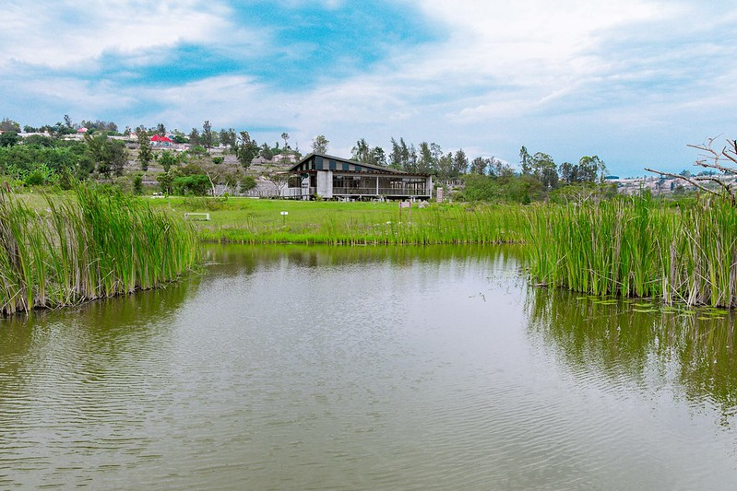The existing Murindi Eco park

These include: The Gikondo wetlands located in Rwandex, Rwampara and Nyabugogo, Gacuriro, Mulindi and Masaka wetlands- which will be worked on to the same level as the recently completed Nyandungu Eco-Tourism park.

“The conservation activities to be done in these designated wetlands will be more than planting trees. They will contain water bodies, ecotourism activities and home for rare, endangered species just as in Nyandungu park to enable city dwellers to relax and enjoy nature,” Kyazze told KigaliToday website.

Work to be done on these designated wetlands is expected to take $40.2million.
The Nyandungu park has network of paths to walk and ride bicycles, boardwalks and bridges in marshy areas, nature viewing areas, bird hides, trails, restaurants and picnic areas.
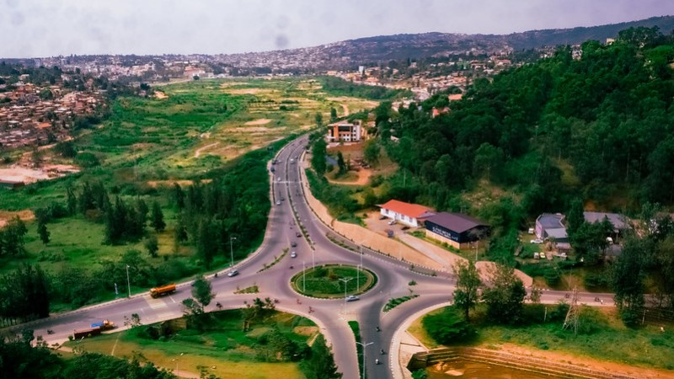Gikondo marshland where industries relocated from, pending rehabilitation of the wetland-Photo Plaisir Muzogeye

After managing to evacuate business activities inside the Rwandex wetland, REMA and the City of Kigali have embarked on rehabilitation and restoration of green life in this area which was occupied by several businesses including factories.
These designated areas have been known to be affected by flooding due to poor and lack of proper water management (up and downhill).

In the meantime, efforts have been embarked on evacuating and expropriation activities in other designated wetlands like Utexrwa and Nyabugogo, which will also be restored as budget lines continue to be available, according to Kyazze.

Under the second round of RUDP, the World Bank and government of Rwanda have committed Rwf160billion in aimed at improving urban settlements through proper management of the environment in the six secondary cities namely; Huye, Muhanga, Musanze, Nyagatare, Rubavu and Rusizi.
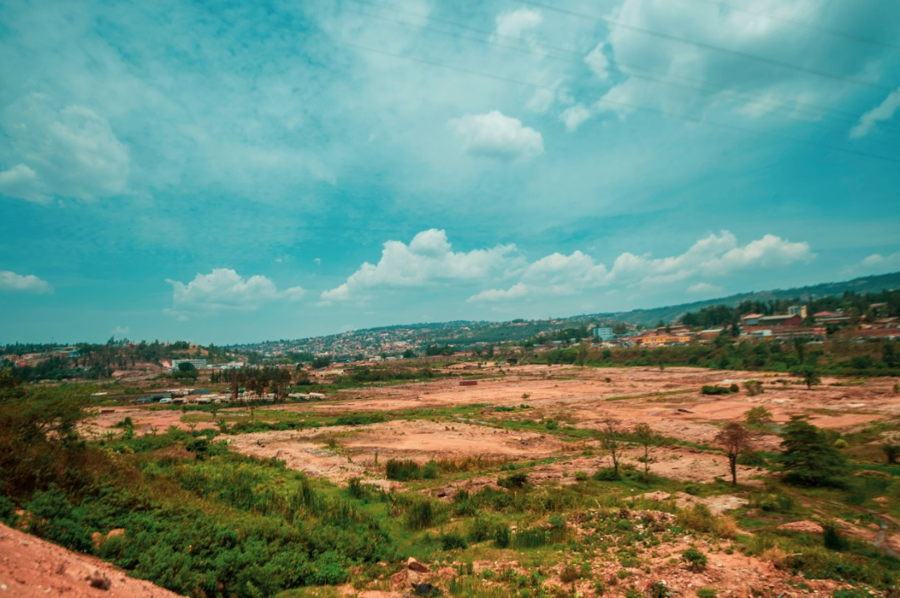Gikondo marshland – photo by Plaisir Muzogeye

Government is expected to contribute counterpart funding (CF) of an equivalent $ 15 million for the financing of resettlement and compensation of anticipated project, affected persons and property (PAPs).

Claver Gatete, the Minister of Infrastructure, said earlier that RUDP 2 will enhance decent settlement in cities as the country seeks to increase urbanization to 30% by 2024 from 17.3% as per the 2019 estimates.

Minister Gatete said RUDP 2 will enhance decent settlement in cities as the country seeks to increase urbanization to 30% by 2024 from 17.3% as per the 2019 estimates.

